难度提升申请报告
作者：王绍宇
学号：5080379072
题目：1.交互式受力分析软件

日期：2010-8-6

目的：希望通过下面的介绍，让老师了解我对本工程高级功能的扩展，并希望提升难度系数，让辛勤的劳动能有相应的回报。

简介：因为原项目并未要求实现3D显示功能以及实时的动态功能。而我觉得加入3D的效果会更真实地反映客观物理世界，并且使观察者（使用者）增添愉悦感，更真切地体会到物理世界的乐趣。
而且我已在3D的基础上实现了实时的动态演示。创建一个物体之后可以立即让它在受力和其它物体的影响下按照物理规律运动，给人无比真实的体验。

功能概述：
下面是已完成的附加功能部分的贴图和说明：

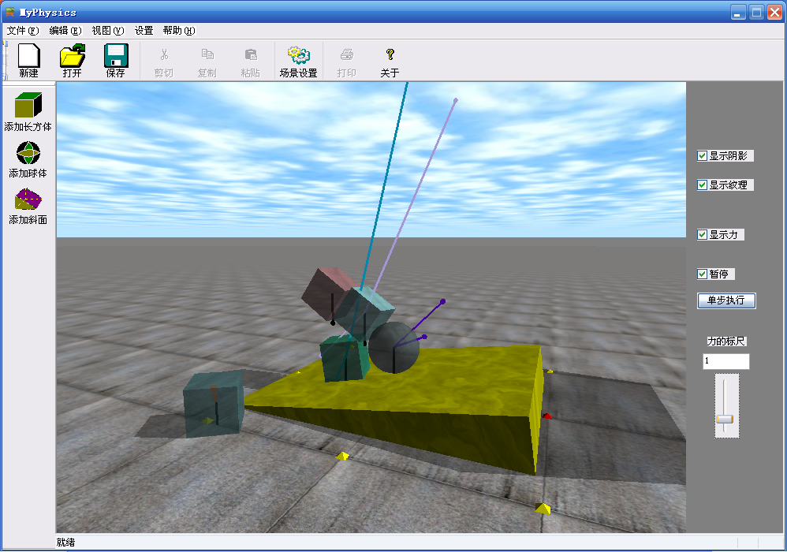

真实3D场景，支持多物体间相互作用。
不同物体间的力用不同的颜色表示，重力统一用黑色表示，清晰，直观，便于分析。鼠标左中右键拖动随意切换视角。物体纹理细腻，天空中云朵还会飘动的哦！
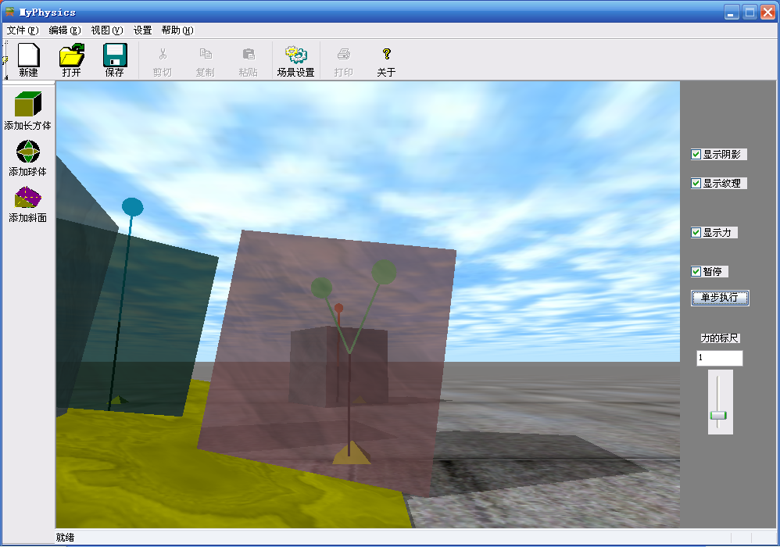

上图中心的物体受斜面和地面的给支持的力，与重力相平衡。
物体的颜色透明度可以自设，以便观察从重心出发的力的线段，并且可以方便观察多个物体位置关系。

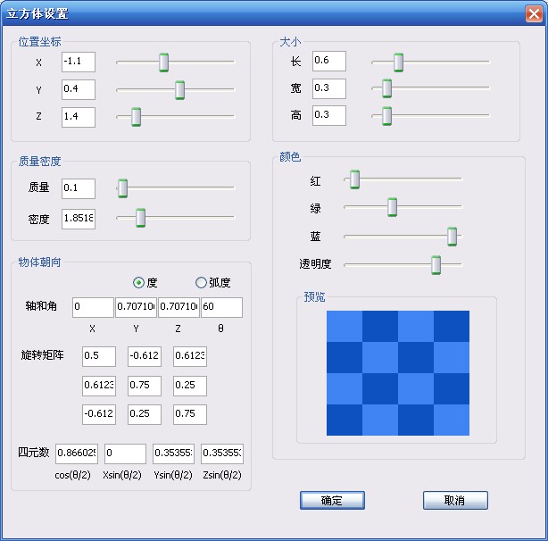

物体的属性设置对话框。
包括物体的位置、大小、质量、密度（质量、密度和计算出的体积三者自动关联同步，更改体积可以自动更新质量）、颜色透明度（有预览）。
3D中不得不考虑的物体朝向问题：这里为了方便用户，有三种输入朝向的方式，第一种“轴和角”比较直观，后两种可以为高级用户准备，由于三种设置方式（“轴和角”“旋转矩阵”“四元数”）会自动相互同步，后两种也可做查询用。不熟悉该设置的用户也不用担心，只要使用默认值即可。

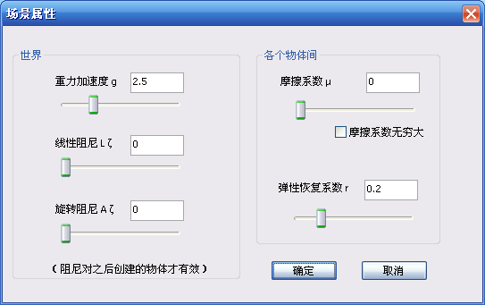

场景属性设置的对话框。
重力的大小可以自己设置，设为0即取消重力。还可以设置物体间的摩擦系数、碰撞的恢复系数等。阻尼可以理解为一个恒定的空气阻力吧，只要平动或者转动就会受到阻碍（通常可以设为0，即无阻尼）。

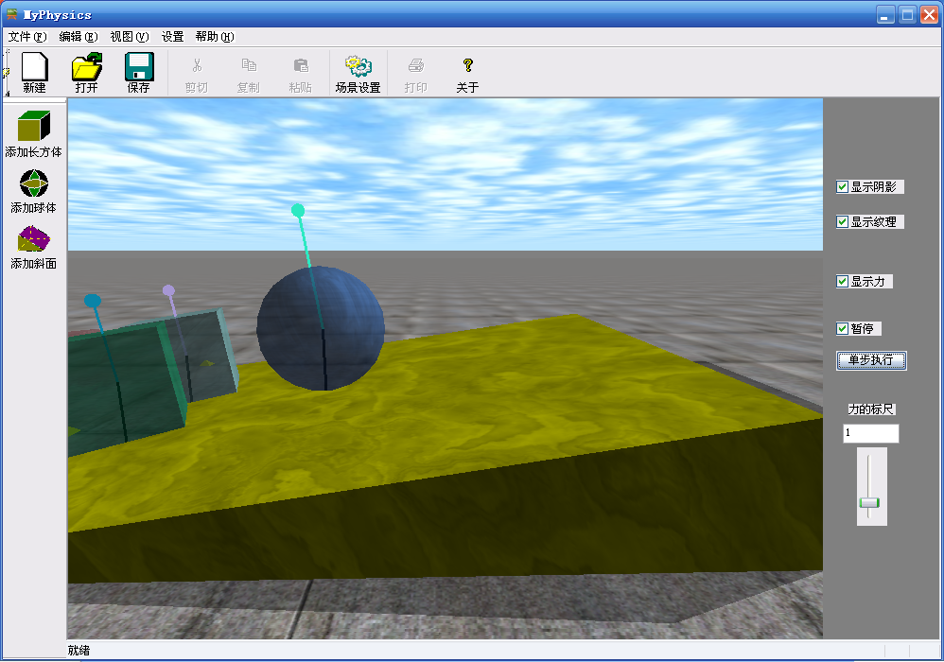

摩擦系数设为0时物体不受摩擦力而只受重力和支持力，进而正在下滑。

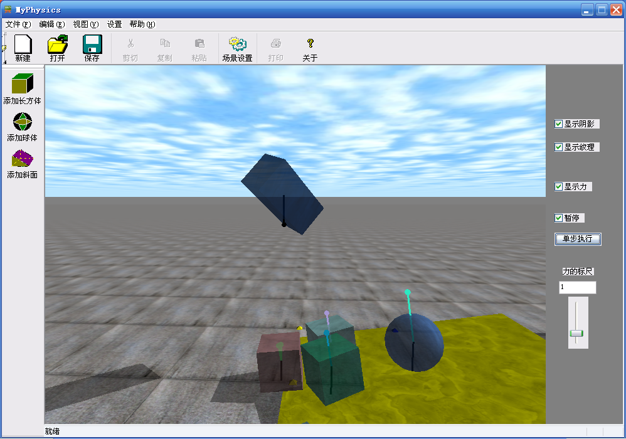

空中的物体正在下落。可以看到它的朝向并非标准的朝向（可以在创建物体时设置）。其它物体正在斜面上下滑（如果这些物体任意两个接触都会发生力的作用）。

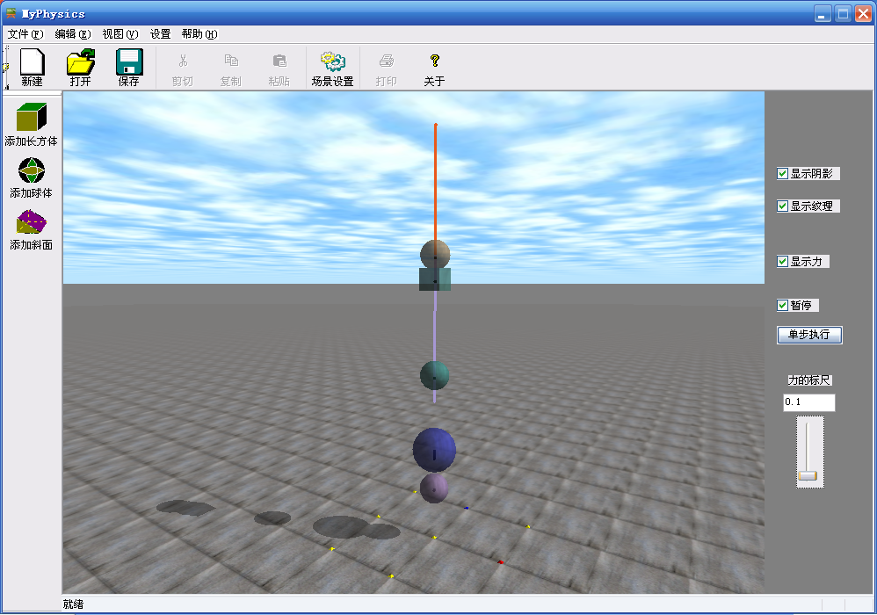

正在进行往复的弹性碰撞演示（受重力）。
力的标尺可以自定义设置，由于物体的短暂碰撞受力的尺度一般比较大，所以线段会特别长，所以，如上图，力的标尺设为较小，可看出物体的重力（黑色）变短。最上面两个物体正在发生碰撞，可看到该相互作用力较大。

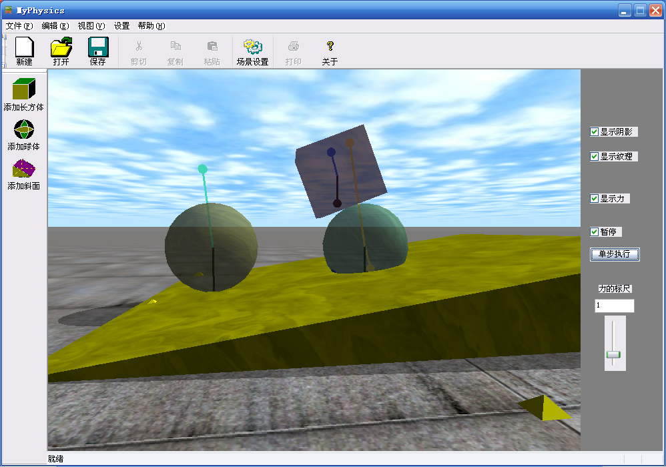

自动的错误纠正
新添加的球体（右）与斜面有重合部分，正在“冒”出来，并且会将原来在斜面上的物块顶起来。这是自动错误的处理，物体有一部分进入到其它物体内部时会自动受力被“挤”出来。

文件导出
可以导出如下格式的文件，保存场景中各个物体的信息以及物体之间的作用情况，以备研究之用。
具体包括整个世界的重力等，每个物体的类型、位置、大小、朝向、线速度、角速度、质量、惯量等等，还有各物体之间的作用力的作用点和力的向量表示等等。

某场景下导出的文件如下：

////////////////////////////// demo.scn /////////////////////////////////////////
-- Dynamics Interchange Format v0.1

Xworld = dynamics.world {
gravity = {0,0,-9.80000019073486},
ODE = {
ERP = 0.2,
CFM = 1e-005,
auto_disable = {
linear_threshold = 0.0001,
angular_threshold = 0.0001,
average_samples = 1,
idle_time = 0,
idle_steps = 10,
},
},
}
Xbody = {}
Xbody[0] = dynamics.body {
world = Xworld,
pos = {-0.0813618642834243,0,0.354724808084243},
q = {0.661345611904123,0,-0.750081316668507,0},
lvel = {-0.000298759272403736,0,1.7347632794984e-006},
avel = {0,-0.00161148289253908,0},
mass = 0.0804247719318987,
I = {{0.00128679635091038,0,0},{0,0.00128679635091038,0},{0,0,0.00128679635091038}},
ODE = {
},
geometry = {
{
type = "sphere",
radius = 0.2,
},
},
}
Xbody[1] = dynamics.body {
world = Xworld,
pos = {-1.73811525686414,-0.0217660340189564,0.148999759150116},
q = {3.67523146975068e-008,0.0658895136782309,-0.997826924865852,4.59611704266119e-008},
lvel = {1.1049517193861e-006,1.49861478798984e-006,-3.19189119579733e-015},
avel = {-9.65657719059019e-006,6.72881796684346e-006,-8.94413453044591e-008},
mass = 0.05,
I = {{0.00075,0,0},{0,0.00075,0},{0,0,0.00075}},
ODE = {
},
geometry = {
{
type = "box",
sides = {0.3,0.3,0.3},
},
},
}
Xbody[2] = dynamics.body {
world = Xworld,
pos = {0.313465265737279,0,0.414564544591265},
q = {0.985700115798992,0,0.168508995943406,0},
lvel = {-0.000213690055840811,0,-7.68215819995366e-005},
avel = {0,-0.00124389982853594,0},
mass = 0.335103216382911,
I = {{0.00536165146212658,0,0},{0,0.00536165146212658,0},{0,0,0.00536165146212658}},
ODE = {
},
geometry = {
{
type = "sphere",
radius = 0.2,
},
},
}
Xbody[3] = dynamics.body {
world = Xworld,
pos = {-1.34777920530497,-0.0221047803813117,0.198998529999288},
q = {0.946905038264472,0.214002568708703,-0.213528721991066,0.109449686981265},
lvel = {-0.00953456812460033,-0.000104030823108336,5.82867087928207e-016},
avel = {0.000520154115541678,-0.0476728406230016,-0.0851353473952857},
mass = 0.15,
I = {{0.0024,0,0},{0,0.0024,0},{0,0,0.0024}},
ODE = {
},
geometry = {
{
type = "sphere",
radius = 0.2,
},
},
}
Xbody[4] = dynamics.body {
world = Xworld,
pos = {-1.26345513755295,5.33609458668502,0.198997898231902},
q = {-0.415427835579525,0.54836987432095,-0.71788682221092,0.106530300191276},
lvel = {-0.00750104787959356,0.25364495606949,4.71844785465692e-016},
avel = {-1.26822478034745,-0.0375052393979678,-0.157553899817728},
mass = 0.214466058485063,
I = {{0.00343145693576101,0,0},{0,0.00343145693576101,0},{0,0,0.00343145693576101}},
ODE = {
},
geometry = {
{
type = "sphere",
radius = 0.2,
},
},
}
Xjoint = {}
Xjoint[0] = dynamics.contact_joint {
world = Xworld,
body = {Xbody[4]}
pos = {-1.26330511659536,5.33102168756363,-0.00100210176809759},
normal = {0,0,1},
depth = 0.00100210176809759,
mu = inf,
bounce = 0.239999994635582,
bounce_vel = 0.02,
}
Xjoint[1] = dynamics.contact_joint {
world = Xworld,
body = {Xbody[3]}
pos = {-1.34758851394248,-0.0221026997648496,-0.00100147000071213},
normal = {0,0,1},
depth = 0.00100147000071213,
mu = inf,
bounce = 0.239999994635582,
bounce_vel = 0.02,
}
Xjoint[2] = dynamics.contact_joint {
world = Xworld,
body = {Xbody[1]}
pos = {-1.90653673994117,0.107207622544174,-0.00100023972821418},
normal = {0,0,1},
depth = 0.00100021590772925,
mu = inf,
bounce = 0.239999994635582,
bounce_vel = 0.02,
}
Xjoint[3] = dynamics.contact_joint {
world = Xworld,
body = {Xbody[1]}
pos = {-1.56969379779873,-0.150739721556946,-0.00100024197155051},
normal = {0,0,1},
depth = 0.00100024197155051,
mu = inf,
bounce = 0.239999994635582,
bounce_vel = 0.02,
}
Xjoint[4] = dynamics.contact_joint {
world = Xworld,
body = {Xbody[1]}
pos = {-1.86708894092051,-0.190187520577607,-0.00100026579203544},
normal = {0,0,1},
depth = 0.00100026579203544,
mu = inf,
bounce = 0.239999994635582,
bounce_vel = 0.02,
}
Xjoint[5] = dynamics.contact_joint {
world = Xworld,
body = {}
pos = {1.06349014417284,0.75,-0.684947406494422},
normal = {0,0,1},
depth = 0.684947406494422,
mu = inf,
bounce = 0.239999994635582,
bounce_vel = 0.02,
}
Xjoint[6] = dynamics.contact_joint {
world = Xworld,
body = {}
pos = {-0.914052011699243,-0.75,-0.98382367144162},
normal = {0,0,1},
depth = 0.98382367144162,
mu = inf,
bounce = 0.239999994635582,
bounce_vel = 0.02,
}
Xjoint[7] = dynamics.contact_joint {
world = Xworld,
body = {}
pos = {-0.914052011699243,0.75,-0.98382367144162},
normal = {0,0,1},
depth = 0.98382367144162,
mu = inf,
bounce = 0.239999994635582,
bounce_vel = 0.02,
}
Xjoint[8] = dynamics.contact_joint {
world = Xworld,
body = {Xbody[2]}
pos = {0.343244910309377,0,0.21755461570384},
normal = {-0.149438132473599,0,0.988771077936042},
depth = 0.000751185268983823,
mu = inf,
bounce = 0.239999994635582,
bounce_vel = 0.02,
}
Xjoint[9] = dynamics.contact_joint {
world = Xworld,
body = {Xbody[0]}
pos = {-0.0516055312137327,0,0.15787880812383},
normal = {-0.149438132473599,0,0.988771077936042},
depth = 0.000918564814777478,
mu = inf,
bounce = 0.239999994635582,
bounce_vel = 0.02,
}
Xjoint[10] = dynamics.contact_joint {
world = Xworld,
body = {Xbody[0],Xbody[2]}
pos = {0.11605682522021,0,0.384645427205941},
normal = {-0.988708354663912,0,-0.149852558929705},
depth = 0.00066542699481531,
mu = inf,
bounce = 0.239999994635582,
bounce_vel = 0.02,
}

////////////////////////////// end of file ///////////////////////////////////////

期望：规定的提升难度系数为0.15～0.25，可是我觉得开发中付出的艰辛远远超过了此限。我期望提升难度在0.3～0.4，希望老师酌情考虑。

